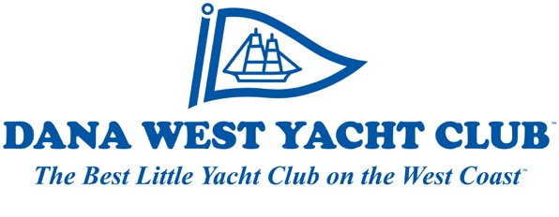
2021 Board of Directors Candidate Form
Due by Sunday September 20, 2020

Instructions: Please fill in the form below and use a maximum of 200 words for your Candidate Statement in Word format. You may use additional sheets as needed. Please also indicate the committees for which you are willing to volunteer. Please return this form with your statement, and a photo of yourself to commodore@dwyc.org no later than September 20, 2020. Any information contained herein, and your photo, may be included with the Ballots sent to members.

Name_____________________________ Member Number___________________________

Candidate Statement

Interested Volunteer Areas

[ ] Juniors [ ] Food and Beverage
[ ] Race [ ] Charity Regatta
[ ] Opening Day [ ] Port events
[ ] Other _________________________________________

