Mark Williams
Junior Sailing President
> Email Mark

Each year Dana West Yacht Club sponsors a Youth Summer Sailing Camp in three 2-week sessions.
The camps are open to all children ages 8-18 (whether club members or not). The camp is held from 9:00am to 5:00pm Monday through Friday. Lunch is provided on Fridays.

Cost: $450 per session.

2020 Junior Summer Sailing Camp Calendar
- Session 1:
June 15th – June 26th
- Session 2:
June 29th – July 3rd
- Session 3:
July 6th – July 17th

Visit the Juniors on Facebook
Purchase your West Marine products online or at any West Marine store and mention DWYC Juniors. The Dana West Youth Sailing Program will receive a commission on each sale. You’ll get the lowest price and the DWYS, Inc. will earn money no matter how you shop.

If you have any questions contact Mark Williams, Junior Sailing President.
Email: juniors@dwyc.org
or call: 949-661-1185 ext. 5#
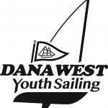
The Dana West Yacht Club Junior Sailing Program is administered by Dana West Youth Sailing, Inc., a 501c3 Non-Profit corporation.
1234

>> Donate to the Juniors ONLINE.
We have a fleet of more than 25 boats that includes: RS Teras, Lasers, CFJ’s and Naples Sabots that are provided free for use at our Summer Camp, Open Sailing in the off season, Wednesday evening harbor racing in the summer, and local regattas throughout the year. Our US Sailing certified instructors grew up at DWYC. They know the club, the harbor, the boats, and each other.
Our Summer Camp is open to children ages 8-18 (Club members or not). The camp is held from 9:00an to 5:00pm Monday through Friday. Lunch is provided on Fridays.

If you have any questions, contact Mark Williams, Junior Sailing President. Email: juniors@dwyc.org or call: 949-661-1185 ext. 5#

2020 Instructors
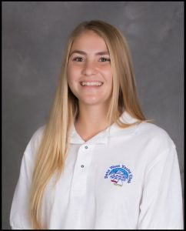  Peyton Lee | 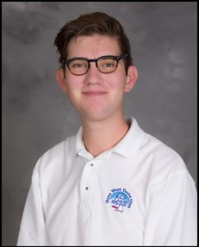  Ben Rightmire
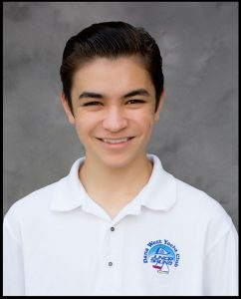  Andrew Schwartz | 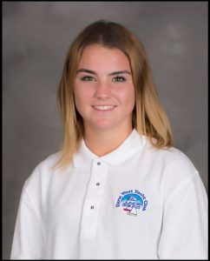  Hailey Balogh

